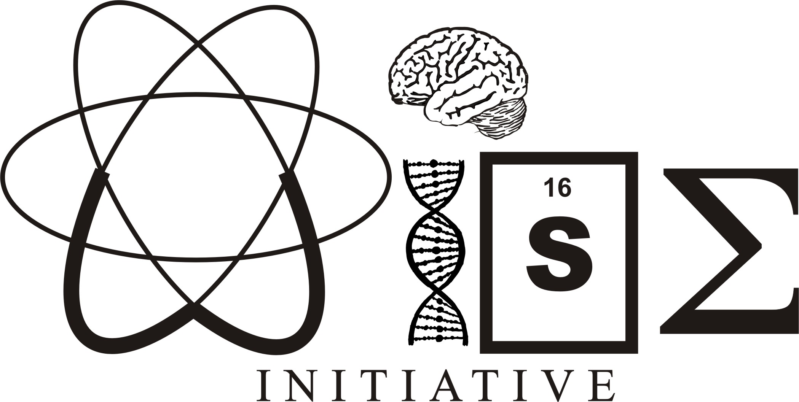

Women in Science and Engineering Initiative

McMaster University

Year End Report 2019-2020

1280 Main Street West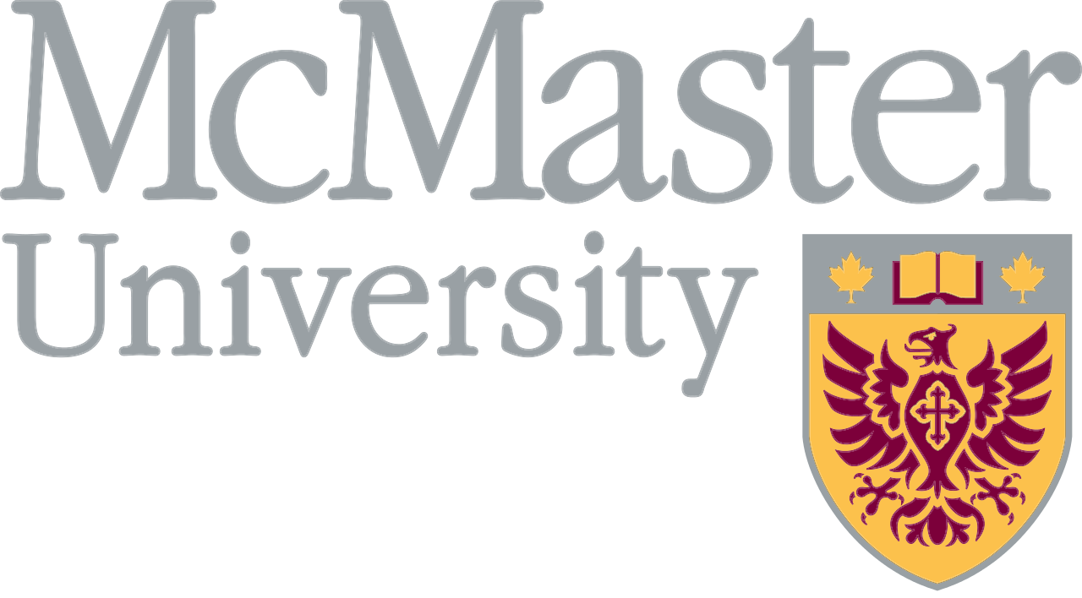

Hamilton, ON L8S 4L8

Email: wiseinitiative@gmail.com

Website: mcmasterwise.com

**THE MCMASTER WISE INITIATIVE**

The WISE Initiative was formed after a survey of female graduate students conducted during the summer of 2006 revealed a strong need for a forum at McMaster University in which female graduate students can identify, discuss, and learn about gender-related issues specific to their field of work and study. In 2019-2020, we successfully moved our cancelled events to virtual platforms, which was a great success over the summer.

**Mission:**

The McMaster Women in Science and Engineering (WISE) Initiative is an integrated network of academics and professionals in science and engineering whose mission it is to support, celebrate and advocate for female-identified and equity-seeking individuals in science, technology, engineering, and mathematics (STEM) at McMaster University.

**Objective & Strategy:**

Our main objectives are to create a supportive network of female-identified mentors, increase issue-specific education for students, and facilitate interdisciplinary collaboration and communication. The WISE Initiative uses a multifaceted approach, through:

**Support:**

* Networking: Social events and Mentor the Month lecture series, as well as a newly introduced Town Hall panel series with our Faculty WISE members, which will continue in the 2020-2021 academic year
* Fostering academics: Professional development workshops and our annual multi-disciplinary research conference (Current Research in Engineering, Science and Technology, *CREST*)
* Showcasing research by undergraduate and graduate students in STEM
* Running outreach programs for students in high school to learn about STEM

**Celebration:**

* Mentor of the Month lecture series, highlighting outstanding female mentors at McMaster and within the Hamilton community
* Panel discussions of invited speakers within academia and industry

**Advocacy:**

* Instigating and facilitating discussion with senior administration regarding female-identified and equity-seeking groups in science and engineering
* Communicating with other WISE groups across Canada
* Hosting events for high school students to encourage them to continue to nourish their love of STEM

### **2019-2020 WISE INITIATIVE STEERING COMMITTEE MEMBERS**

|  |  |  |  |
| --- | --- | --- | --- |
| **Name** | **Position** | **Department** | **Email** |
| Adrienne Atayde | CREST Coordinator | Medical Sciences | ataydeal@mcmaster.ca |
| Julie Bannon | Steering Committee | Psychology, Neuroscience, & Behaviour | bannonj@mcmaster.ca |
| Stefania Cerisano | Co-President | Psychology, Neuroscience, & Behaviour | cerisas@mcmaster.ca |
| Isabella Churchill | Outreach Coordinator | Medical Sciences | churchi@mcmaster.ca |
| Maha Dogar | Mentor of the Month Coordinator | Integrated Science | dogarm@mcmaster.ca |
| Lisa Dyce | WISE Advisor | Neuroscience | dycel@mcmaster.ca |
| Negeen Halabian | CREST Coordinator | Psychology, Neuroscience & Behaviour | halabian@mcmaster.ca |
| Rachelle Ho | VP FInance | Psychology, Neuroscience & Behaviour | homr@mcmaster.ca |
| Abigail Jacob | Social Events Coordinator | Health Science | jacoba16@mcmaster.ca |
| Patrycja Jazwiec | Steering Committee | Biochemistry & Biomedical Studies | jazwiepa@mcmaster.ca |
| Bronte Johnson | Steering Committee | Health Science Education | johnsb11@mcmaster.ca |
| Tovah Kashetsky | Steering Committee | Psychology, Neuroscience & Behaviour | kashetst@mcmaster.ca |
| Daeria Lawson | Mentor of the Month Coordinator | Health Research Methodology | lawsod3@mcmaster.ca |
| Ginny Liu | Steering Committee | Medical Sciences | liuz15@mcmaster.ca |
| Lulu Lu | VP Internal | Global Health | luj10@mcmaster.ca |
| Katie Mackett | Steering Committee | Medical Sciences | macketka@mcmaster.ca |
| Sitara Sharma | Co-President | Kinesiology | sharms99@mcmaster.ca |
| Veronica Tran | Steering Committee | Biochemistry | tranv14@mcmaster.ca |
| Kara Tsang | Graphic Design & Social Media Coordinator | Biochemistry & Biomedical Sciences | tsangkk2@mcmaster.ca |
| Inna Ushcatz | Outreach Coordinator | Medical Sciences | ushcati@mcmaster.ca |
| Mai Wageh | Steering Committee | Kinesiology | wagehm@mcmaster.ca |
| Iris Wang | Social Events Coordiantor | Manufacturing Engineering | wang993@mcmaster.ca |
| Jennifer Williams | VP External/  Mentorship Coordinator | Kinesiology | willijs3@mcmaster.ca |

For a directory of the 2020-2021 Committee, please see our **2020-2021 Prospectus**.

**WISE INITIATIVE EVENTS (2019-2020)**

**WISE New Member Information Night (September 11th, 2019)**

Our first social of the year was a meet-and-great for new members and interested members to get to know each other and the current team. It was held at the Phoenix.

**Mentor of the Month Lecture Series (November 2019 - July 2020)**

In October 2014, WISE launched our Mentor of the Month lecture series where a female-identified or equity-seeking mentor is invited to lead an interactive discussion on career development, gender equity, and/or non-academic aspects of their lives in STEM.

This past year’s mentors and topics included:

* Dr. Patricia Liaw (Department of Medicine): “Ideas for achieving a work-life balance in academia” (November 7, 2019)
* Dr. Sharon McNicholas (Department of Mathematics and Statistics): “An unconventional path to a career in academia” (December 5, 2019)
* Beth Bandler (Magellan Aerospace Corporation): “My science-inspired legal and business career” (February 14, 2020)
* Dr. Chad Harvey (School of Interdisciplinary Science): “Mental health, stress, and perceived student stressors in academia” (June 17, 2020)
* Dr. Baraa Al-Khazraji (Department of Kinesiology): “Finding work-life balance and your research inner voice” (July 15, 2020) – a STEM Stories event

**WISE Winter Social (November 26, 2019)**

To celebrate coming to the end of the fall semester, WISE held an ornament-painting event. The aim of this event was to provide a safe space for female-identified individuals and allies in STEM to meet and network in a casual setting. Furthermore, it provided students with a more intimate setting to talk with the WISE executive team to learn more about our mission, objectives, and upcoming events. Approximately 20 undergraduate and graduate students were in attendance.

**Generation STEM – High School Outreach (November 30, 2019)**

In 2018, WISE introduced a new high school outreach program called Generation STEM (GenSTEM). GenSTEM was open to all in grades 9-12 interested in Science, Technology, Engineering, or Math (STEM).  This year’s conference was structured as an interactive, activity-centered day where students had the opportunity to participate in workshops lead by faculty and graduate students from a variety of departments at McMaster. Nearly 30 students attended and were given an introductory presentation in the Planetarium in BSB. This was followed by workshops workshops in Mathematics and Statistics; Kinesiology Brain Stimulation; Kinesiology Exercise Physiology; Biochemistry; and Electron Microscopy. There was also a tour of the Nuclear Reactor.

**WISE Mentorship Event (January 22, 2020)**

Our mentorship event started with a workshop by Catherine Maybrey (“Networking for Introverts”) followed by a chance to try out our new networking skills at a dinner meet-and-great at the Phoenix. This was the start of a new mentorship initiative that has continued as Coffee & Conversations, where undergraduate and graduate students can meet with STEM faculty mentors on a regular basis to chat about science, life, and being women in academia.

**Paint Night and Origami Social (February 27, 2020)**

This was another social event for students in STEM to meet one another in a safe space, and to do fun activities. This time, it was a Bob Ross follow-along pain night as well as fun paper-folding patterns.

**WISE Current Research in Engineering, Science, and Technology**

**(CREST) Annual Meeting (August 4-7, 2020)**

Our 13th annual research conference (CREST) had to be postponed and moved to a virtual platform this year. The event was originally planned for March 13-14, 2020, but we had to cancel it the day before due to Covid-19. Luckily, we had an amazing team to help us move everything online, and we were able to have our conference online in August instead.

We hosted workshops, panels, and keynote speaker (Dr. Jenny Campos from the University Health Network and Toronto Rehabilitation).

Below are detailed highlights of each of the events held at the conference.

**Keynote Speaker:**

Our Keynote Speaker this year was Dr. Jenny Campos, Canada Research Chair (Tier 2) in Multisensory Integration and Aging, Chief Scientist at Toronto Rehab’s KITE Initiative at the University Health Network. Dr. Campos studies mobility in walking and driving under realistic and challenging conditions. She is also the Director of iDAPT Young Innovators, which is a youth outreach program.

Dr. Campos’s talk, titled “Seeing, Hearing, Thinking, and Moving: A Balancing Act for the Brain” walked us through her path from being a graduate student in the Department of Psychology, Neuroscience & Behaviour here at McMaster to becoming the Chief Scientist at the Challenging Environments Assessment Laboratory at Toronto Rehab. She also taught us about her research and how it impacts everyday life and aging.

**Research Presentations**

Unfortunately, we weren’t able to schedule in student research presentations at our virtual conference this year.

**Workshops**

This year, our workshops were: Life after undergrad, which was co-hosted by McMaster’s WiSTEM team; Envisioning success, which was led by Katheryne Stewart from Science Career and Cooperative Education at McMaster; Entrepreneurship, which was led by Fran Lasowski; and Science communication, which was led by Dr. Katie Moisse.

**Career Panels**

Our panels were Equity and Inclusion (co-hosted by McMaster’s WiSTEM); and Industry (with panellists Dr. Clare Armstrong, Dr. Gay Yuyitung, Dr. Colleen Strain, and Melanie Demers).

**WISE Faculty Town Hall Meeting (August 11, 2020)**

As a new initiative from WISE, we’ve teamed up with our Faculty WISE Advisors to present Town Hall meetings where a panel discusses current events. This first Town Hall addressed the impacts of Covid-19 on equity, diversity, and inclusion in higher education. The panel consisted of Dr. Joanna Wilson, Dr. Deborah Sloboda, Dr. Juliet Daniel, and Dr. Vernice Downey. We look forward to continuing this new initiative into the 2020-2021 year.

**GenSTEM Science Summer Camp Highschool Outreach (August 24-29, 2020)**

We held four online workshops and a panel for our Generation STEM outreach this summer. The workshops were: Fun with Fractals, led by Julie Jenkins from Math & Stats; Build Your Own Telescope, led by Blake Ledger from Physics & Astronomy; Microbiology, led by Allison Guitor from Let’s Talk Science; and 3D Animation, led by Sebastian Himbert from Physics & Astronomy. We also held a panel of WISE members and workshop leaders to talk about post-secondary science education with the high school students.

**FINANCIAL REPORT (2019-2020)**

The WISE committee approached various internal and external sources to raise the

necessary funds to cover our budget. We were thrilled to receive many positive words of

encouragement for our initiative and were able to raise over $6,000! **A full list of our 2019-2020 Sponsors can be found in Appendix 1.**

**TABLE 1: General Expenses (2019-2020)**

|  |  |
| --- | --- |
|  | **Item Total** |
| Social Events:   * Winter Social ($120.57) * Paint Night Social ($247.68) | $368.25 |
| CREST conference*:   * Supplies ($154.88) * Workshop/Panel/Keynote Thank you gifts ($255.00) | $409.88 |
| Generation STEM Outreach:   * Supplies and food ($217.35) * Planetarium ($150.00) * Thank you gifts ($75.00) | $442.32 |
| Mentor of the Month:   * $233.44 X 3 in-person talks | $700.32 |
| Mentorship:   * Phoenix Networking Event | $720.97 |
| Website, Merchandise, Printing, etc:   * Printing ($59.92) * Merchandise ($627.52) | $687.44 |
|  |  |
| **Total Expenses** | $3,329.18 |

* CREST is usually a much larger expense than this (upwards of $5,000), but because our in-person meeting was cancelled and our events were instead held online, we saved money on room bookings, food, and other physical logistics for the event

**APPENDIX 1**

**WISE INITIATIVE 2019-2020 SPONSORS**

The WISE Initiative committee would like to extend their great appreciation to the following McMaster sponsors, without whom our goals would be impossible to achieve.

##### 

**Diamond Level (> $1000)**

Office of the Dean and Associate Dean, Science *(Faculty of Science)*

**Diamond Level ($1000)**

Office of the Provost and Vice-President (Academic)

Office of the Vice-President Research

**Gold Level ($500 – $999)**

McMaster Graduate Student Association (GSA)

**Silver Level ($250 – $499)**

McMaster Alumni Association

Canadian Union of Public Employees (CUPE) Local 3906

**Donations in Kind**

McMaster University Campus Store

**APPENDIX 2**

**2018-2019 Events**

WISE New Member Information Night (September 12th, 2018)

Mentor of the Month:

* Dr. Katie Moisse: “Work-life balance; transitioning from academia to journalism and back” (October 10, 2018)
* Dr. Audrey Hicks: “Making Stepping Stones out of Roadblocks” (November 20, 2018)
* Dr. Catherine Maybrey: “Introduction to Career Planning” (January 17, 2019)
* Dr. Mel Rutherford: “Queer-in’ Academia” (February 20, 2019)
* Dr. Judith Shedden: “Everyday Resilience” (April 25, 2019)
* Dr. Cécile Fradin: “Science in the Time of #MeToo” (May 9, 2019)
* Dr. Julie Marr: “Where do you see yourself in…” (July 4, 2019)

WISE Winter Social (December 5, 2018)

WISE Current Research in Engineering, Science, and Technology (CREST) Annual Meeting (May 16-17, 2019)

Generation STEM (GenSTEM) Highschool Outreach (November 24, 2019)

Living Library Highschool Outreach (March 9, 2019)

**2017-2018 Events**

WISE New Member Information Night (September 12, 2017)

Mentor of the Month:

* Dr. Rosa daSilva: “Being Ready for Opportunities: It’s Not All About Luck!” (December 6, 2017)
* Dr. Elizabeth Hassan: “The Power of Positive Framing” (January 30, 2018)
* Dr. Kalaichelvi Saravanamuttu: “How Can We Make Mentorship More Inclusive?” (March 2, 2018)
* Dr. Romina Brignardello-Petersen: “Securing Advantage from Disadvantage” (April 26, 2018)
* Dr. Heather Sheardown: “The Joys and Perils of Working with Industry” (June 27, 2018)
* Dr. Sara Andres: “The Advantages and Opportunities of Graduate School” (July 17, 2018)

WISE Winter Social: Mug Decorating & Holiday Movie Night (December 14, 2017)

WISE Current Research in Engineering, Science, and Technology (CREST) Annual

Meeting & EngSci Girl  (March 9-10, 2018)

WISE Summer Social: McMaster Nuclear Reactor Tour & Refreshments at the Phoenix! (July 10, 2018)

**2016-2017 Events**

WISE New Member Information Night (September 20, 2016)

Mentor of the Month:

* Susan Searls Giroux: “The University We Are For” (October 5, 2016)
* Kim Jones: “Shifting Gears - The Benefits of a Crooked Path” (November 16, 2016)
* Gillian Goward: “ Going Incognito: Using Merit to Minimize Gender Identity and Succeed in a Professional Career” (December 14, 2016)
* Sarah Dickson: “Maintaining Work-life Balance” (January 26, 2017)
* Emily Cranston: “ How to land your dream job, even if you’re not sure what it is yet!” (February 15, 2017)
* Judith West-Mays: “Getting out of the comfort zone” (April 19, 2017)
* Alison Sills: “The Third Pillar” (May 24, 2017)
* Dawn Bowdish: “Speaking as an expert...Finding your scientific voice and using it for the greater good” (June 21, 2017)
* Irina Pushkareva: “Finding YOUR Way” (July 19, 2017)

WISE Winter Social: Cookie-Decorating and Hot Chocolate (December 7, 2016)

WISE Current Research in Engineering, Science, and Technology (CREST) Annual

Meeting & EngSci Girl  (March 10-11, 2017)

WISE Summer Social: McMaster Museum Tour & Refreshments at the Phoenix! (July 27, 2017)

**2015-2016 Events**

New Member Information Night (September 10, 2015)

Mentor of the Month:

* Meet the Faculty Mentors Social (October 28, 2015)
* Michelle Dion: “Networking: Why it’s (always) important, why we (sometimes) hate doing it, and how to do it effectively (more often) (November 11, 2015)
* Kathryn Grandfield: “What I learned through international research” (December 9, 2015)
* Deborah Sloboda: Work-life integration for female academics” (January 20, 2016)
* Natalia Nikolova: “Challenges faced by female academics in male-dominated disciplines” (February 24, 2016)
* Maureen MacDonald and Stuart Phillips “An expose of married academic life” (April 21, 2016)

**WISE INITIATIVE EVENT HISTORY (CONTINUED)**

* Elizabeth Rowan: “My time working in government” (May 18, 2016)
* Sandra Montiero: “Finding work-life balance in academia – A personal story of success” (June 22, 2016)
* Sorina Dumitrescu: “Reflections on my journey from student to academic” (Jul 20, 2016)

December Social (December 15, 2015)

WISE Current Research in Engineering, Science, and Technology (CREST) Annual

Meeting (March 10-12, 2016)

WISE August Social (August 18, 2016)

**2014-2015 Events**

New Member Information Night (September 9, 2014)

Mentor of the Month (October 2014 - August 2015)

Cookie Decorating Night (December 15, 2014)

WISE Current Research in Engineering, Science, and Technology (CREST) Annual

Meeting (March 6-7, 2015)

Girls in Science Day (April 10 & 24, 2015)

Regional WISE Student Gathering (August 15, 2015)

Tour the McMaster Nuclear Reactor Facility with WISE (August 19, 2015)

**2013-2014 Events**

Meet n’ Mingle Reception - for Students & Faculty (October 2, 2013)

Pottery Painting Night (November 28, 2013)

Whidden Lectures at McMaster: A Conversation with Joanna Aizenberg (January 21,

2014)

Tour the McMaster Nuclear Reactor Facility with WISE (February 12, 2014)

WISE Current Research in Engineering, Science, and Technology (CREST) Annual

Meeting (March 7-8, 2014)

**2012-2013 Events**

Meet n’ Mingle Reception - for Students & Faculty (October 23, 2012)

Planetarium Show (November 20, 2012)

Meet n’ Mingle 2 Reception - for Students & Faculty (January 23, 2013)

WISE TED Talk Night (February 27, 2013)

WISE Current Research in Engineering, Science, and Technology (CREST) Annual

Meeting (April 5-6, 2013)

**WISE INITIATIVE EVENT HISTORY (CONTINUED)**

**2011-2012 Events**

Student/Faculty “Meet & Mingle” Reception (September 14, 2011)

Movie & TED Talk Night (October 19, 2011)

WISE Colloquium (November 16, 2011)

WISE Charity Trivia Night (December 7, 2011)

Planetarium Show (January 18, 2012)

WISE Initiative 2012 CREST Conference (March 2nd & 3rd, 2012)

WISE TED Talk Night (April 18, 2012)

'Muffins n Mentors' (November 30, 2010 - January 14, 2011)

'Muffins n Mentors' - Dr. Terri Lewis (October 26, 2011)

- Dr. Leyla Soleymani (December 5, 2011)

**2010-2011 Events**

Welcome Pub Night (September 15, 2011)

Student/Faculty “Meet & Mingle” Reception (October 20, 2010)

TED Talk Night (November 17, 2010)

'Muffins n Mentors' (November 30, 2010 - January 14, 2011)

"1 Piece of Advice" (December 8, 2010)

Planetarium Show (January 20, 2011)

“A Treatment for Death by PowerPoint” (March 3, 2011)

WISE Initiative 2011 CREST Meeting (March 11-12, 2011)

'Muffins n Mentors' - Dr. Robin Cameron and Dr. Alison Sills (November 30, 2010)

- Dr. Laurel Trainor and Dr. Sue Becker (January 14, 2011)

- Dr. Sheila Singh (March 3, 2011)

**2009-2010 Events**

WISE Student/Faculty Meet & Mingle (October 29, 2009)

WISE Dinner and Movie Night, "Water" (November 10, 2009)

WISE Potluck and Movie Fundraiser (December 2, 2009)

WISE Initiative 2010 International Women's Day Conference (March 5-6, 2010)

**2008-2009 Events**

WISE Movie Night, "The Women" (April 8, 2009)

WISE Initiative 2009 International Women's Day Conference (March 6-7, 2009)

WISE Mentor Event (December, 2008)

**WISE INITIATIVE EVENT HISTORY (CONTINUED)**

WISE Movie Night, "Asking Different Questions: Women and Science" (November 10,

2008)

Welcome Social at the Hub (October 29, 2008)

**2007-2008 Events**

WISE Initiative 2008 International Women's Day Conference (March 7 & April 19, 2008)

Movie Night, "Gorillas in the Mist" (February 7, 2008)

WISE Initiative Colloquium 2007: Fall Term

Movie Night, "Proof" (November 21, 2007)

WISE Initiative Social at the Hub (September 18, 2007)

**2006-2007 Events**

WISE Initiative International Women's Day Conference (March, 2007)

WISE Initiative Colloquium 2006-07: Fall Term

WISE Initiative Colloquium 2006-07: Winter Term

WISE Initiative Round Table Conference, (September, 2006)